Monday | Tuesday
1. Jack lives on a farm and has a large backyard. The area of his rectangular backyard is of a square mile. If the width of the yard is of a mile, what fraction of a mile is the length of the rectangular backyard? ( A = lw) | 1. William is putting up signs on the edge of the road every of a mile. He just put a sign down and he has of a mile of road left in which to place his signs. He wants to determine how many more signs he should put on the edge of the road.  William should put up more signs.
2. Ms. Winter makes homemade bath soaps and bottles of lotion. In her inventory, she has 48 bath soaps and 64 bottles of lotion. She wants to use all of her inventory to make as many gift baskets as she can using the same number of bath soaps and the same number of lotion bottles in each gift basket. (Hint: Find the GCF)  She will be able to make at most gift baskets. Each basket will contain bath soaps and bottles of lotion. | 2. Harry is making gift bags for a holiday party using two types of candies. He has a total of 84 chocolate candies and 56 peppermint candies. Each gift bag he makes will be the same.  If Harry uses all of his candy, he can make at most gift bags. Each gift bag will have chocolate candies and peppermint candies.
3. The coordinates of point P are (-3, 5). Point R is a reflection of point P across the x-axis. Point S is a reflection of point P across the y-axis.  Point R is located in quadrant. Point S is located in quadrant. | 3. In which quadrant does the point (-11, -22) lie?
4. Solve the expression below. | 4. Solve the expression below  3 × 2² + 2 ÷ 2 - (1.2 + 5.6)
5. Simplify the following expression.  8(8 + 2x) + 13 | 5. Simplify the following expression.  (14x + 5) - 6x
Wednesday | Thursday
1. Jenny needs of a stick of butter for a recipe. She cuts the half-stick of butter into four equal pieces. What portion of the whole stick of butter is each of the pieces? | 1. Wendy is creating a large soup based on a recipe. Her recipe calls for of a pint of milk, but she only has of a pint of milk, so she can only make a portion of her soup.  Wendy can only make of her recipe with the amount of milk that she has.
2. What is the greatest common factor (GCF) of 60 and 84? | 2. What is the greatest common factor (GCF) of 96 and 56?
3. Plot the following points on the coordinate plane.  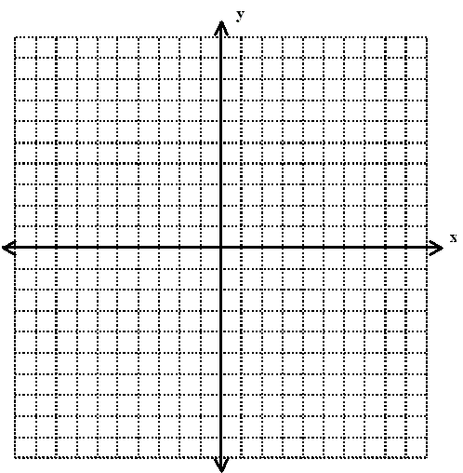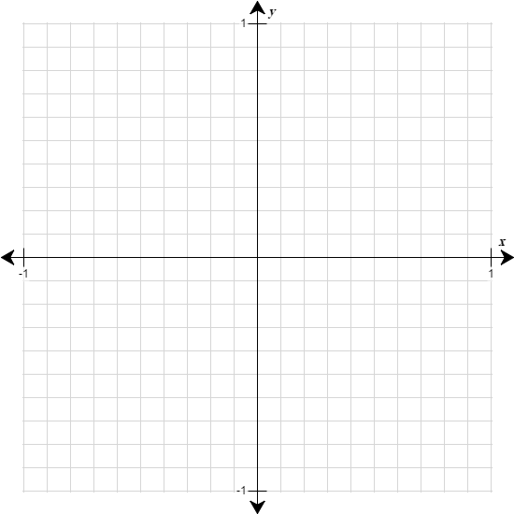  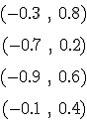 | 3. In which quadrant does the point (-11, 22) lie?
4. Solve the expression below.  $8 x 4^{2 }$- (6 + 12) ÷ 2 | 4. Solve the expression below  6 × 2² + 12 ÷ 2 - (1.2 + 5.6)
5. Simplify the following expression.  5(3 + 2x) + 17 | 5. Simplify the following expression.  (10x + 7) - 6x

