- Find the area of the Rectangle  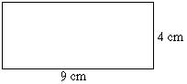  14cm  8cm  - 64 cm² C. 116 cm²  - 44 cm² D. 112 cm² | 2.) Mr. Pass decided to sow his yard in grass. In order to do so he needs to know the area of his backyard. What is the total area of his backyard?  5 ft  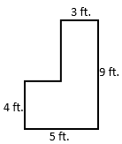  9 ft  12 ft  A. 2160 sq. ft. C. 96 sq. ft.  B. 80 sq. ft. D. 76 sq. ft.
3.) Find the area of the shaded triangle on the right side of the trapezoid.  7 in  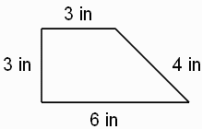  7 in  12 in  6 in  A. 36 in² C. 17.5 in²  B. 16.5 in² D. 35 in² | 4.) Find the area of the pentagon. Round to the nearest square inch. The figure is NOT drawn to scale.  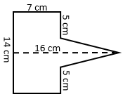  A. 80 cm² C. 180 cm²  B. 40 cm² D. 116 cm²
5.) Find the Volume of the rectangular prism in centimeters.  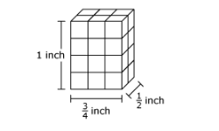  A. $\frac{3}{8}$ in³ C. $\frac{1}{2}$ in³  B. $\frac{8}{9}$ in³ D. 3 in³ | 6.) The net shown folds to form a rectangular prism. Determine the surface area of the prism.  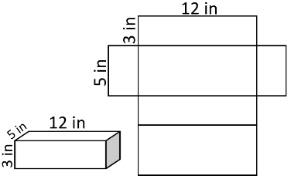  A. 222 cm² C. 20 cm²  B. 24 cm² D. 180 cm²
7.) Which solid figure does the net represent?  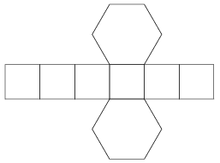  A. cube C. triangular prism  B. Pentagon D. Hexagonal prism | 8.) What is the surface area of an ice cube that has 2 cm sides?  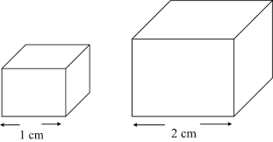  A. 24 cm² C. 4 cm²  B. 8 cm² D. 48 cm²
9.) Rectangle PQRS will be drawn on the coordinate grid. Where should point S be located?  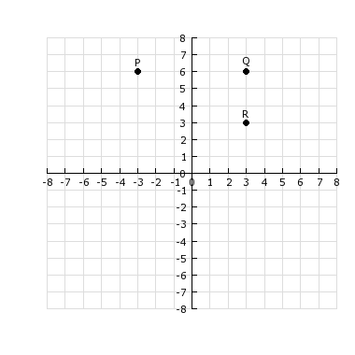  A. (3, 3) C. (3, -3)  B. (-3, 3) D. (-3, -3) | 10.) Susan made the following 3D figure from a net. What is the 3D shape?  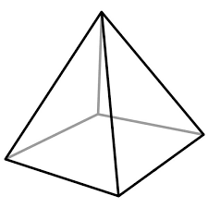  A. Triangular Pyramid C. Triangular Prism  B. Rectangular Prism D. square pyramid
11.) Find the volume of the given rectangular prism.  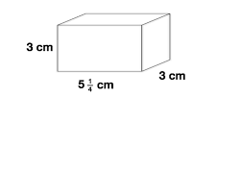  A. $47\frac{1}{2} {cm}^{3}$ C. $47\frac{1}{4}{cm}^{3}$  B. $45 {cm}^{3}$ D. $11\frac{1}{4} {cm}^{3}$ | 12.) The Volume of a rectangular prism is $144 {cm}^{3}$. The height of the prism is $6 cm$. The width is 3 cm. What is the length of the prism?  A. $12 {cm}^{}$ C. $8 {cm}^{}$  B. $7 {cm}^{}$ D. $10 cm$
13.) Use the net as an aid to compute the surface area of the triangular prism.  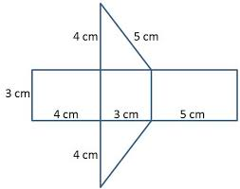  A. 61 cm² C. 76 cm²  B. 48 cm² D. 66 cm² | 14.) Use the net below to find the surface area of the square-based pyramid.  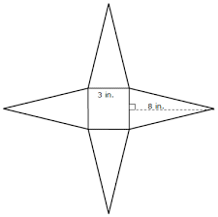  A. 54 cm² C. 57 cm²  B. 105 cm² D. 102 cm²

Formulas
Area Formulas  Rectangle: $A=lw$ Square: $A=s^{2}$  Triangle: $\frac{1}{2}bh$ Parallelogram: $A=bh$ | Volume Formulas  $V=lwh$ OR $V=Bh$

